System Architecture

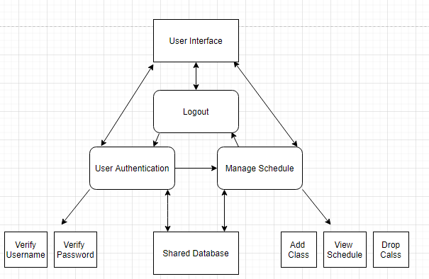

User interface starts at Login screen

User Authentication - User Login

* Authenticates username
  + Verify username
* Password Authentication
  + Verify user’s password

Manage Schedule

* Add class - Student can add class to schedule
* Drop class - Student can remove class from schedule
* View Schedule - Student can view schedule

Logout

* Logs the student out of application, resetting all temporarily stored information and returning to login screen.

Shared Database

* Hold course information
* Student information
* Professor information
* Hold user login information